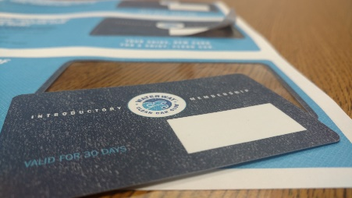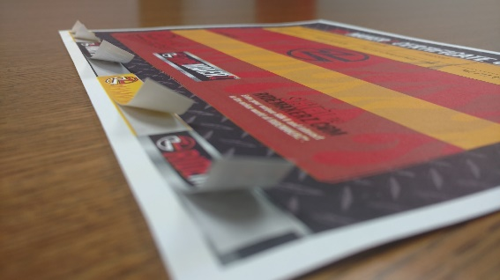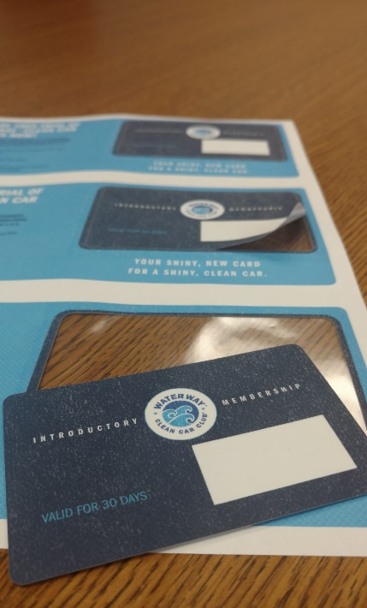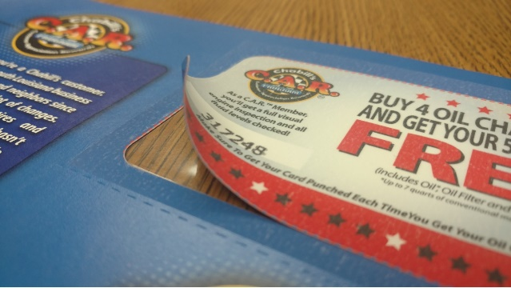****

523 S. Meyer Ave. Valmeyer, IL 62295

800-851-4460 www.margraphics.com

**Integrated cards, coupons and labels…**

* **Tactile & Interactive**
* **Functional**
* **Increase response rates**
* **Effective**

***This & That…***

**Laminates**

Available in gloss or matte

1 mil std face lam (1/2 and 2 mil available)

2 mil std for integrated card back

Thinner performs better in imaging & processing

**Carriers**

Available from 60# uncoated to 9 pt coated

Most common is 70# uncoated for cards

Consider adding ties for heavy carriers

**Production notes**

* Created by utilizing a split laminate.
* The base carrier sheet and integrated element are printed at the same time on a UV web press on rolls (benefit: *guaranteed color match carrier to element*).
* The laminate(s) is applied over the carrier then die-cut to create the peel-out element on a web finishing line.
* Based on the caliper of the carrier and laminates, integrated cards are typically 6.5 to 8 mil when removed but can be up to 12 mil.
* Permanent, removable & specialty adhesives available for integrated labels

**Tech Talk: *Integrated Cards, Coupons & Labels***

**Think…*Membership & ID Cards, Coupons, Client/Donor Loyalty Programs, Stickers, Product ID,***

***Direct Mail, Peel-N-Stick, Shipping Labels, Associations, Passes, …and so much more!***